**The Standards**

**A physically literate individual…**

**STANDARD 1** Demonstrates competency in a variety of motor skills and movement patterns.

**STANDARD 2** Applies knowledge of concepts, principles, strategies and tactics related to movement and performance.

**STANDARD 3** Demonstrates the knowledge and skills to achieve and maintain a health-enhancing level of physical activity and fitness.

**STANDARD 4** Exhibits responsible, personal and social behavior that respects self and others.

**STANDARD 5** Recognizes the value of physical activity for health, enjoyment, challenge, self-expression and/or social interaction.

<https://www.ccsoh.us/Page/2249>



Columbus

City

Schools

Physical and Health Education Professional Development

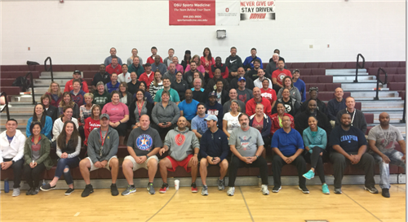

November 5, 2019

South HS

**8:15-8:45: Café**

Sign-in and general announcements.

**9:00-11:00: Café**

**HS Health ED**

**Columbus Public Health**

Injury Prevention, Driving Simulator and Table for resources.

**9:00-11:00: MS Gym**

**Elementary PE**

**K-5 USA Field Hockey** **Pilot Program**

ES Small Sided Games

**9:00-11:00: HS Gym #1**

**Middle and High School PE 6-12 ADA Sports & Rackets:** This is designed for MS/HS teachers as it relates to net games and fitness activities.

**9:00-11:00: HS Gym #2**

**6-12 Lacrosse** Coach Barry Davis, ***Urban Lacrosse Academy*** and former head coach, Ohio Machine, basic skills and small sided lacrosse games.

**9:00-10:00 Room 170**

**Adapted Physical Education,** Q&A/Round Table with APE Teachers.

**9:00-10:00 Room 168**

**Everfi, Online Health Education Free courses,** Michelle Fugate

**10:00-11:00 Room 168**

**HS Hands-only CPR**

American Heart Association, Diana Briggs

**10:00-11:00: Room170**

**MS 7th grade, Teen Reproductive Health Education Pilot Program**

Celebrate One

**10:00-11:00 Room 176**

**Opioid Abuse Prevention**

Mr. King

**11:30-12:30: LUNCH**

|  |
| --- |
| **November PD Theme**  Teaching Games for Understanding (TGFU)  K-12 PE Teachers will acquire knowledge and skills in **Net/Wall**, **Target** and **Striking** during small sided games. This PD will address **Standards 1 and 2 in the ODE PE Evaluation.**  The aim of TGfU model is to combine tactical awareness and skill execution to help students become better sport game players. |

**1:00-3:00: MS Gym**

**Middle and High School PE**

**6-12 USA Field Hockey Pilot Program**

MS/HS small sided games in PE and basic skills

**1:00-3:00: HS Gym #1**

**Elementary PE**

**K-5 ADA Sports & Rackets:** This is designed for Elementary teachers as it relates to net games and Fitness.

**1:00-3:00: HS Gym #2**

**K-5 Lacrosse** Coach Barry Davis of the Urban Lacrosse Academy and former head coach of the Ohio Machine will provide basic skills and small sided lacrosse games.

**1:00-2:00 Room 168**

**NAMI of Franklin Cty.** “Ending the Silence”, Tamisha and Teyah McKenzie

**1:00-2:00: Room170**

**MS 7th grade, Teen Reproductive Health Education Pilot Program**

Celebrate One

**1:00-2:00 Room 176**

America Lung, Yoga, Brittany

**3:15-3:30 Evaluation and Sign-out**