**8:15-8:45: Main HS Gym**

Sign-in, introductions, and general announcements.

**9:00-11:30: HS Gym**

**Elementary PE**

**K-5 US Tennis Association**

All teachers that are participating should have registered prior to the workshop. Small sided games in PE

**9:00-11:30: MS Gym**

**Middle and High School PE 6-12 US Games- Roundnet:** This is designed for HS teachers as it relates to Spikeball and other net games.

**11:30-12:30: LUNCH**

**October PD Theme**

Teaching Games for Understanding (TGFU)

K-12 PE Teachers will acquire knowledge and skills in **Net/Wall**, **Target** and **Striking** during small sided games. This PD will address Standards 1 and 2 in the ODE PE Evaluation.

Learning through games, not about games, motivates students. The aim of TGfU model is to combine tactical awareness and skill execution to help students become better games players.

**1:00-3:00: MS Gym**

**Elementary PE**

**K-5 US Games- Roundnet:** This is designed for Elementary teachers as it relates to Spikeball and other net games.

**12:30-3:00: HS Gym**

**Middle and High School PE**

**6-12 US Tennis Association**

All teachers that are participating should have registered prior to the workshop. Small sided games in PE

**1:00-3:00: HS Gym #2**

**Elementary PE**

**K-5/6 Columbus Blue Jackets (PowerPlay Challenge):** Elementary teachers will participate in this ongoing CBJ hockey program.

**3:15-3:30**

**Evaluation and Sign-out**

**The Standards**

**A physically literate individual…**

**STANDARD 1** Demonstrates competency in a variety of motor skills and movement patterns.

**STANDARD 2** Applies knowledge of concepts, principles, strategies and tactics related to movement and performance.

**STANDARD 3** Demonstrates the knowledge and skills to achieve and maintain a health-enhancing level of physical activity and fitness.

**STANDARD 4** Exhibits responsible, personal and social behavior that respects self and others.

**STANDARD 5** Recognizes the value of physical activity for health, enjoyment, challenge, self-expression and/or social interaction.

<https://www.ccsoh.us/Page/2249>



Columbus

City

Schools

Physical and Health Education Professional Development

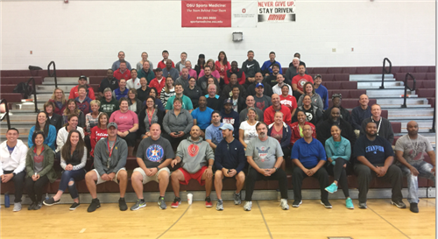

October 18, 2019

South HS