February Newsletter

Beechcroft Cougar

News

6100 Beechcroft Rd., Columbus, Ohio 43229 https://www.ccsoh.us/beechcrofths T: (614)365-5364

“Hold fast to dreams, for if dreams die, life is a broken winged bird that cannot fly.” – Langston Hughes

Upcoming Events
February 12th
90 Minute Early Release Day

February 17th
No School – President’s Day

February 28th
Black History Program

Beechcroft Boys Initiative (BBI) Showing Leadership
Beechcroft Boys Initiative members served as mentors/judges for 4th and 5th Graders at the Northgate Intermediate School’s Invention Convention.

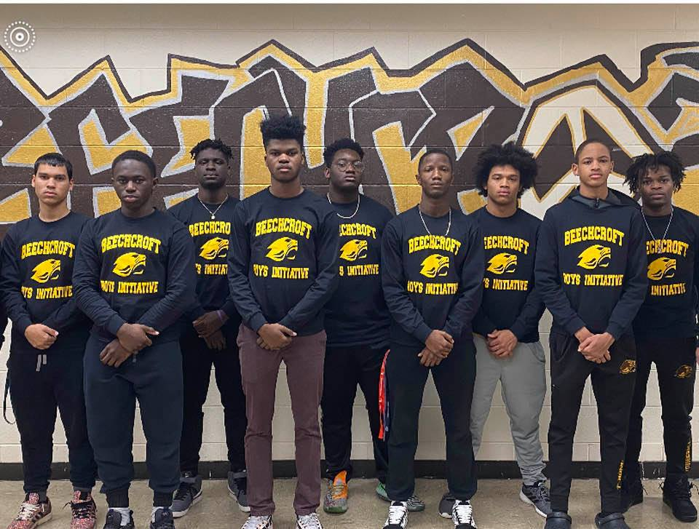

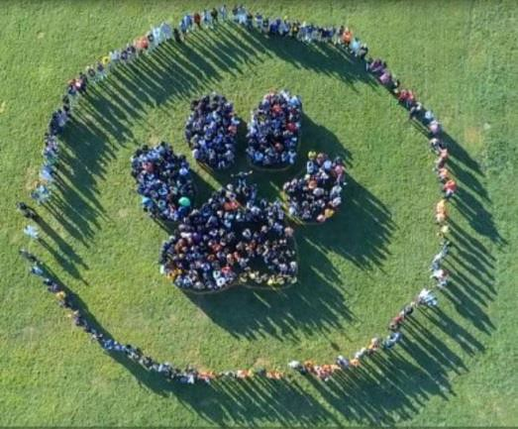
#BEechcroftAmazing!
Beechcroft Community
We Are Safer Together!
Call or text 844-SAFER-OH. If you see something, say something.
Student/Parent Portal Access
Information
Student Information
- Visit the CCS Website: www.columbus.k12.oh.us
- Click on the Student Tab
- Scroll down to “Student Portal.”
- Username = Student ID#
- Password = Student Date of Birth eg: 11-11-2001
Parent Information
- If you have not received your child’s activation key, contact the school office.
- Visit the CCS Website: www.columbus.k12.oh.us
- Click on the Parent Tab
- Scroll down to “Parent Portal.”
- Click on “First Time Using Campus Portal.
- Enter Activation Key
- Will then prompt you to create a user name and password that will be your new log in.
Folllow us on Twitter
@BHSBeAmazing
NetJets is Partnering with CCS and BHS

NetJets is partnering with CCS to introduce a new mentoring program with students interested in STEM to identify and problem-solve a sustainability issue. Sustainability focuses on meeting the needs of the present without compromising the ability of future generations to meet their needs. Eight Beechcroft Students will have the opportunity to extend their learning outside of the classroom through this opportunity.

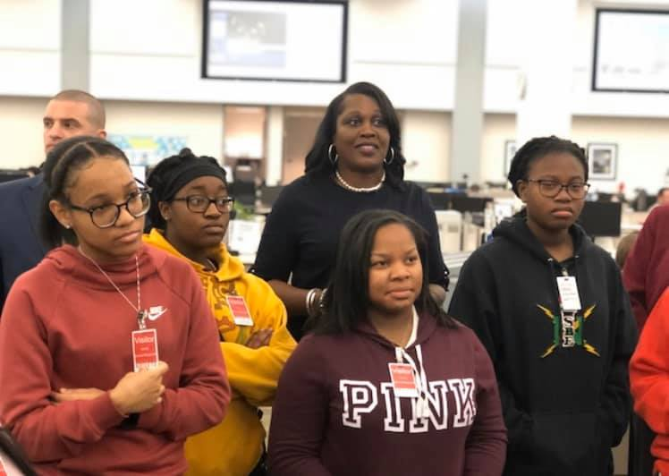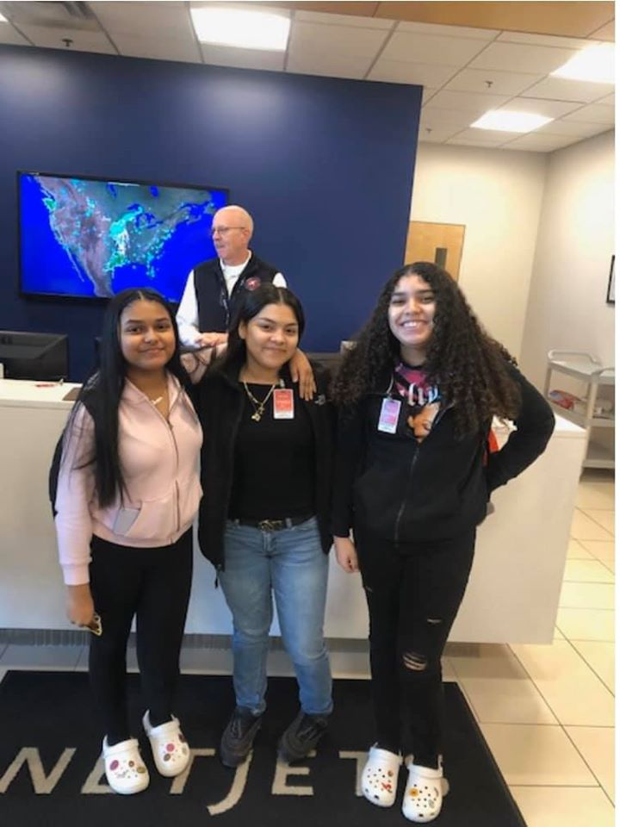

Please Consistently Monitor Your Child’s Grades in Infinite Campus

Beechcroft Teachers will enter grades into the Electronic Gradebook as soon as practicable following the due date of the assignment. As a result, allowing teachers the opportunity to provide timely feedback to students.

The Campus Portal can be accessed through the following URL address: https://campus.columbus.k12.oh.us/campus/portal/columbusCity.jsp

