**2500 N. Cassady Avenue** 

**Columbus, OH 43219**

**(614) 365-5456**

**Amber Hall Principal**

**Marshella Barrett Secretary**

**Cassady Family Handbook**

**2024-2025**

**Introduction**

Dear Parents and Students,

The staff at Cassady Elementary 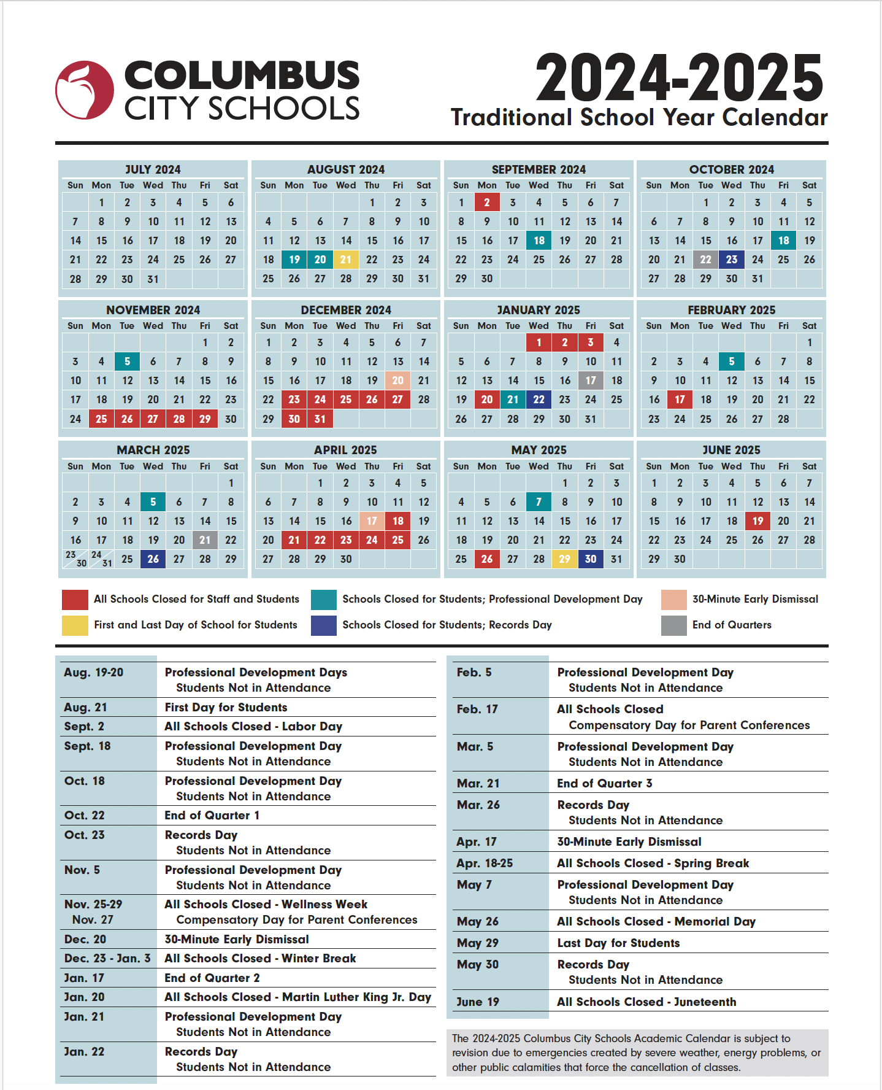School would like to welcome you to the new school year! We hope and trust that this will be a successful, satisfying and enriching school year for you and your child. This handbook has been prepared to give you some helpful information about the school year. It contains important dates, policies, procedures and expectations. It is designed to provide you with information to help you navigate and support your child this school year. **Additionally, refer to Columbus City Schools Guide to Student Success.** This Guide to Student Success provides an overview of the important policies put in place by our Columbus Board of Education, as well as the rules and guidelines that are designed to promote safe, secure and nurturing learning environments for all students.

**Vision:**

Each child will develop a curiosity of learning, discover their interests and grow in their love of learning; by doing so students will reach a year or more of growth.

**Mission:**

Cassady exists to create a challenging learning environment that encourages high expectations for success through developmentally-appropriate instruction that allows for individual differences and learning styles. Our school promotes a safe, orderly, caring, and supportive environment.

**Core Values**

* **Cassady shows respect to all individuals that come through our doors.**
* **We will strive for the success of every member of the Cassady community.**
* **We promise to create an environment where all students and families feel like they belong.**

**Absences/Attendance Policy**

Student success in school depends on good attendance and getting to school on time. Acceptable excuses for student absences are:

1. Personal illness
2. Doctor or dentist appointment
3. Death of an immediate family member

Ohio Law requires schools to make contact each day a student is absent for any amount of time for any reason. Parents must notify the school by 9:30 a.m. on the day of the absence. A note is required each time a child has been absent from school stating the reason for the absence and signed by the parent or guardian. Ohio Law (HB 410) recently changed how Columbus City Schools must track missed class time. No longer are absences tracked only by the number of days your child has missed. The definition of “habitual truant” changes from days to hours. The new definition is:

a. Absent 30 or more consecutive hours without legitimate excuse

b. Absent 42 or more hours in one school month without legitimate excuse

c. Absent 72 or more hours in one school year without legitimate excuse

The law also includes” excessive absences” where a parent or guardian will be notified if a

student is:

d. Absent 38 hours or more in one school month with or without legitimate excuse

e. Absent 65 or more hours in one school year with or without legitimate excuse

f. Students missing more than 10% of the school year may be retained

**School Hours**

**School Office Hours 8:30-3:45**

**School Schedule**

8:30 a.m. . . . . . . . . . . . . . . . . . . . . . . . . Breakfast

9:00 a.m. . . . . . . . . . . . . . . . . . . . . . . . . Tardy Bell

11:45 . . . ….. . . . . .Pre K, K, 2 and 4th Grade Lunch

12:15 . . . . . . . . . . . . . . . 1st, 3rd and 5th Grade Lunch

3:15-3:35 . . . . . . . . . . . ………….... . . . Dismissal

**School Safety and Visiting**

**We welcome your presence here at Cassady!**

All visitors must sign in at the main office during school hours using our Lobby Guard kiosk system. To do this you must have a valid ID such as a driver’s license or state issued ID. If you do not have an ID or do not sign in using the system you will not be permitted to visit Cassady. This is for the safety of all our students and staff and is a district policy. All visitors must wear the visitor’s sticker they receive from Lobby Guard. Cassady welcomes family and community involvement in our school and encourages families and community members to visit, volunteer and conference with staff. However, because of the potential interruption and disruption of our students’ education posed by uncontrolled or unexpected classroom visitations or conferences the following guidelines have been adopted as policy:

1. **All visitors must check in at the office upon entering the school. All visitors must sign in to Lobby Guard and speak with office staff prior to being in the school.** Parents should not just walk through the doors at the front (even if they are open). Visitors must come to the front office.
2. **Visitations and conferences must be by prior arrangement.**
3. Teachers have the right to reschedule a visitor when prior arrangements have not been made.
4. Visitors must always maintain civility and model appropriate behavior for students. Visitors that fail to maintain appropriate behavior will receive a warning about their conduct and may be issued a no-trespass letter from Columbus City Schools.

We want our parents/guardians involved in school and we want to make you feel welcome at all times. We understand the need to have good communication between home and school and hope to fulfill that expectation. With that in mind, you are welcome to visit your child at any time but must schedule ahead of time and refrain from interrupting classroom instruction.

**Student cell phones**

**Students are not to have cell phones on them at any time. No exceptions**. **Cell phones are to be left in the student's book bag turned off.** Students are permitted to bring cell phones to school. We can’t be held liable for missing or broken cell phones. If a phone is found or removed from a student it will be available in the office for pickup by a parent/guardian. Communicate this expectation to your students and parents.

**Arrival and Dismissal**

1. Students should arrive between 8:45 and 9:00 a.m. unless they participate in the breakfast program which starts at 8:30 a.m.
2. Students who arrive after 9:00 a.m. will be considered tardy, except for late bus arrivals. All late arrivals must report to the office before going to class.
3. It is crucial for students not to arrive prior to 8:30. There is no supervision prior to 8:30. The doors are unlocked at 8:30. Students will not be permitted into the building under any circumstances prior to 8:30 a.m.
4. At 8:30 the morning patrol will direct students to the cafeteria to eat breakfast or wait in the designated area for the bell.
5. All notes from home requesting change in dismissal must go to the office, also if dismissal changes please call the office before 3:00.
6. Please do not pick up students prior to 3:00 as these minutes will count as an absence. Please wait outside in your car for your child’s dismissal.
7. The office will be closed between 3:00-3:30 pm. This is a very busy time for our secretary.
8. Parents should not just walk through the doors at the front (even if they are open). Visitors must come to the front office.
9. Dismissal will begin at 3:15.
   1. Walkers will be dismissed at 3:18 out the back playground doors.
   2. Car riders and daycare will be dismissed at 3:20. There will be a bus lane and a car lane out front. The inner lane will be for buses only and the outer lane will be for car riders and daycare. Parents will **remain** in their cars. Staff will ask who you are picking up, staff will then call the students via walkie-talkie and a staff member will then walk the children to the car.
   3. Do not leave your car unless you are parked in a designated parking space.
   4. You must pick up your students from the car rider line. We will not be walking students over to the Howard Center parking lot for parents to pick them up there. If you park at the Howard Center you will need to walk over and pick up your student.
   5. Bus riders will be dismissed when their bus arrives.
10. All students must be picked up before 3:35. There are no staff members on duty after that time. Please call ahead if an emergency arises. In accordance with state law all staff members are mandated reporters to Franklin County Children’s Services. We are required by law to report children left unsupervised; therefore, it is crucial to communicate with the office when an emergency occurs. Please communicate this to your daycare provider.

**Bus Transportation**

All transportation routing is done by the district’s Transportation Office. Questions pertaining to bussing should be done through that office. **The phone number is 614-365-5074.**

**Bus Rules**

(School expectations/rules apply during student transportation.)

The bus driver is responsible for the management and safety of students and enforcing the rules. The disorderly student shall be reported to the principal. The principal will be responsible for notifying the parents that continued disorderly conduct can result in suspension of bus riding privileges and/or other disciplinary action.

**Bus Guidelines**

Students should arrive at the designated bus stop 10 - 15 minutes prior to arrival of the bus.

1. Plan with your child for the first day and throughout the school year. If a bus is late arriving, instruct your child on what to do. During inclement weather provide your child with appropriate instructions on what to do. When there is an emergency or early school closing, instruct your child on what to do if they arrive home and you are not there.
2. Cooperate with school authorities to encourage and assure the appropriate conduct of your child.
3. Make sure that your child has a name tag which includes address, phone numbers and bus stop. Attach this to their backpack.
4. K-2 students must be met at their stop by parent or designee.

**What to do if your child is extremely late coming home on the bus . . .**

1. Allow time for the bus to arrive after its scheduled time. It could be delayed due to inclement weather or heavy traffic. Stay at the stop.
2. Call the homes of your child’s friends to determine if he/she is visiting another child.
3. Make sure you know the child’s bus route (number). Call the transportation office at **614-365-5074.**

**If your child misses the bus going to school . . .**

Please instruct your child on what to do if this should occur. Designate a neighbor or friend who the child can go to for help when you are not home.

**If your child misses the bus leaving the school . . .**

Parents will be contacted to pick up the child.

**If you plan to pick up your child at the close of school . . .**

Please send a written note to the teacher and school office.If we have no written notification from a parent, your child will ride the bus as usual. Please do not call the office after 3:00 p.m. to make changes to how your child will go for the day.

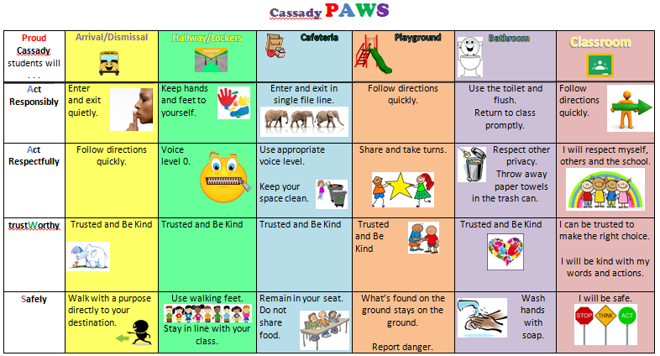

**Student Expectations**

**Cassady Cheetah PAWS**

**P**roud Cassady students **A**re responsible, respectful, trust**W**orthy and **S**afe! Please see the matrix for details. Take the time to work with your child on the school expectations. Please also see the Guide to Student Success for additional Columbus City School guidelines.

Cassady has school-wide expectations for all areas of the school. Please review these expectations with your child. We also have a clear system for rewarding students who meet school expectations and intervening with students that fail to meet the expectation. Additionally, Cassady has a trained crisis intervention team. Team members are trained to de-escalate students and keep them from hurting themselves and others. Reference the above chart for specifics.

**Uniforms**

**Students are expected to be in school uniform every school day.** When students are out of uniform phone calls will be made so that a uniform can be brought to school for the student. Our school uniform is bottoms in navy blue or khaki, tops in navy, light blue or white. All sweaters, sweatshirts, hijabs, dresses, etc. worn inside during the school day must adhere to school uniform colors. School uniforms can be purchased at Target, Family Dollar, Walmart and many other stores. You can also sign up for Charity Newsies 614-263-4300.

**Cell Phones**

Students are permitted to bring cell phones to school. **Cell phones are to remain in backpack and off during school hours while on school property. There is no exception to this expectation. We can’t be held liable for missing or broken cell phones. If a phone is found or removed from a student it will be available in the office for pickup by a parent/guardian.** Families it is important that you monitor your child’s phone and social media use.

**School-wide/Classroom Parties/Celebrations**

School-wide parties occasionally may be held to observe special occasions or festivals. Parents are advised through office or classroom communication when these parties are scheduled.

**Birthdays**

**Families must communicate with the classroom teacher prior to bringing anything to the classroom**. Classroom disruption will not be permitted unless prior arrangements have been made with the classroom teacher.

**Cold Weather/School Closing**

Announcements regarding the emergency closing of school will be made on radio and TV no later than 6:30 a.m. on the day of the closing.

**Immunizations**

Ohio law dictates that all children entering the Columbus City Schools must be immunized against the following diseases:

1. D.P.T. (diphtheria, whooping cough, tetanus) basic series plus the kindergarten booster (3 shots) and a booster.
2. Polio (for everyone) basic series of oral vaccines and a booster (total of 4 vaccines).
3. Rubeola (old-fashioned or 10-day measles), Rubella (German measles), and Mumps all given after the first birthday. This is commonly called the MMR. A total of 2 MMR vaccines are required, at least one month apart.
4. The Hepatitis-B series must be completed (a total of 3 vaccines).
5. All children from foreign countries are required to have a tuberculin skin test within one year prior to enrollment.

**Homework Policy**

Homework may be assigned by the classroom teacher for any of the following reasons:

1. Unfinished class work
2. Strengthen specific skills
3. Enrich specific subject areas

Students have the responsibility for knowing the assignment, having needed materials, doing the assigned work and getting it turned back to the teacher on time. Please familiarize yourself with the homework policy of your child’s classroom. The support of the parent/guardian is important when homework is assigned. Helping the child find a quiet place to study and checking over their assignments can be a great help. Be generous with praise for all the work well done. By doing this, you will help your child feel greater satisfaction in having completed the assignment.

**Library Books, Textbooks and Supplies**

Students are expected to take care of books and supplies. They are responsible for lost or damaged library and textbooks.

**Lost and Found**

To avoid lost clothing or other items, **we suggest that all personal items be marked with the child’s name.** All lost and found items placed in the lost and found.

**Medication**

Students who must take daily medication must have the appropriate forms signed by the physician and parent before the medication can be brought to school. The medication and form must be left in the office. Medication must be received in its original container.

**Communication**

When calling the school please note that most teachers are not available from 8:45-3:45 because they are in the classroom or on duty supervising students. We have created a document to fill out so that staff can respond appropriately to your question or concern. Our secretary, Ms. Barrett will give the document to the appropriate staff member. Staff will return your call within 24 hours. Our office is open Monday – Friday from 8:30-3:15. It is also strongly recommended that you sign up for Class Dojo. This app enables you to directly text your child’s teacher at any time. Additionally, each staff member has a district email that will be communicated with you. Please call ahead or arrange a time to meet with our staff. Please see our school visitation policy. Our school's phone number is 614-365-5456.

Our staff use Class Dojo to communicate with families. This is a free app that can be downloaded to your phone. This is the recommended way to communicate with school staff.

**iReady**

Students are expected to get 50 minutes in reading and 50 minutes in math a week. This is just 10 minutes a day. They will have opportunities to complete this at school. Every week we have Fun Friday and only students that get their 50 minutes plus 2 lessons passed will get to participate.

Getting 50 minutes in each week can help your student grow over a year in each subject. Please make this a priority.

*In accordance with Every Student Succeeds Act (ESSA) and Ohio Revised Code (ORC) 3319.074 law regarding the professional qualifications of teachers, parents have the right to: 1. Request the professional qualifications of your child’s teachers and paraprofessionals; 2. Receive notification if your child’s teacher is not highly qualified; and 3. Have access to your child’s individual performance level on the statewide assessments and individual report card that lets you know how your child is progressing*