 | Getting up in the morning | Getting to school | Clean-up time | Time to relax | Homework time | Mealtime | Getting ready for bed
H  HELP OUT | Make Your bed  Clothes in hamper | Have your backpack, lunch, notes, keys | Do your chores | Clean up after yourself  Play quietly | Put your things in your backpack when finished | Set the table Put dishes away | Brush your teeth Dirty  clothes away
O OWN YOUR BEHAVIOR | Get up on time  Get cleaned up and dressed on time | Be ready to leave on time | Clean up after yourself | Ask before you borrow  Ask to change stations | Complete your homework on time  Do your best! | Use kind words and “I statements”  Recognize mistakes and apologize | Get to bed on time!
M  MANNERS COUNT | Try a morning SMILE!  Thank your parents for helping. | “Thanks for the ride”  “Have a nice day” | Ask politely for help | Respect others things  Offer to share | Ask for help respectfully  “Thanks for the help” | Please and thank you  Use your napkin | End the day with nice words and thoughts
E | V | E | R | Y | D | A | Y

PBS Home Matrix

 | Getting up in the morning | Getting to school | Clean-up time | Time to relax | Homework time | Mealtime | Getting ready for bed
H
HELP OUT
O OWN YOUR BEHAVIOR
M
MANNERS COUNT
E | V | E | R | Y | D | A | Y

The ________ Family Matrix
Write your last name in the blank.
Respectful

Responsible

Safe

Directions: Create an at home family matrix to help your child transition to school. First give your matrix a title. Next, write your school’s expectations in the first left column. Then write your locations in the top column. Lastly, use pictures and positive words to describe behaviors you want to see at home. When finished post the matrix is a visible space (hint: refrigerator) and practice using it matrix daily.
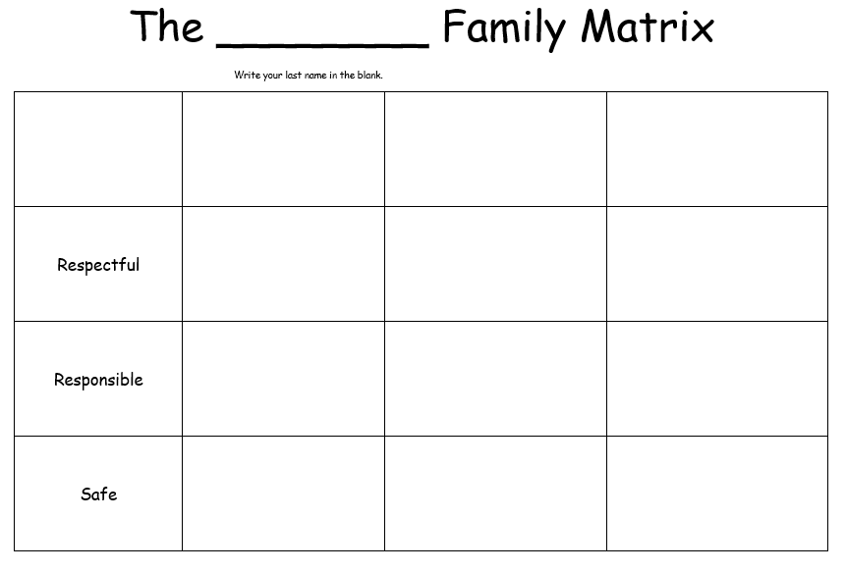
Describe desired behaviors
Locations
Expectations

The ________ Family Matrix
Write your last name in the blank.
Respectful

Responsible

Safe

