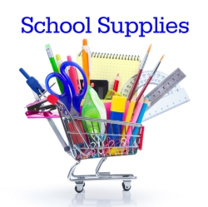
Winterset Elementary
2021-2022 Supply List
Third Grade
Mrs. Concitis & Mrs. Burke

1 handheld pencil sharpener
3 pink erasers
2 24 pack Crayola crayons
1 package colored pencils
2 Composition notebooks (no spiral bound, please)
1 pair scissors
3 glue sticks
3 plastic folders in red, blue, & yellow
1 pencil box (8”x 5”x 2”)
1 pair of headphones
3 boxes of Kleenex
1 container Clorox wipes
1 package baby wipes

___________________________________________________________________
*We have been in touch with Marc's on Henderson Road to have these lists available*

Ohio Tax Free Weekend begins August 2021! Tax Free Weekend 2021 Ohio starts on Friday, August 6th and ends on Sunday, August 8th, 2021. During this time only, you can buy certain items and not pay any sales or use tax. These items fall into the following categories:
- Clothing <$75: All clothing less than $75 will be tax-free. You can buy any number of clothing items under $75, since the exemption applies to the individual price of an item. The same applies to school supplies and instructional material.
- School supplies <$20: Any individual school supply or instructional material that costs no more than $20.
- While most items of clothing are included in the sales tax holiday, things like accessories and sports equipment are not included.

