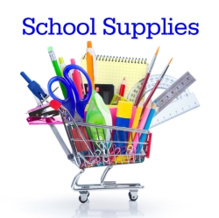
Winterset Elementary

2022-2023 Supply List

Mrs. Hammer

Enclosed you will find the list of school supplies your student will need for this school year. Please send these supplies with your child on the first day of classes!

- Pencils- 24 (twenty four) #2
- Plastic pencil box
- 1 box of 24 crayons
- 12 glue sticks
- 1 pack of markers
- 1 box colored pencils
- 2 bottles of glue
- 2 boxes tissues
- 1 one-inch binder
- 1 bottle (7.5 oz or more) hand sanitizer
- 2 SOLID colored 2 pocket folders (with nothing written on them)
- 2 containers HAND wipes (like Wet Wipes)
- 3 containers of antibacterial wipes (such as Lysol, etc.)
- A complete change of clothes to keep at school
- Pull-ups and wipes (if needed)

