EAHS & 12th Grade Summer Reading 2019

Part One: You will need to read one book from each category (realistic fiction/mystery, speculative fiction, non-fiction). While you are reading, write down the following: 3 observations about real life you got from the book, 3 quotes you liked, 3 questions you have about the novel (plot, events, or ideas that come up in the novel), 3 general comments or connections to the real world, and a one page reaction/reflection on the book as a whole in a 70-page spiral notebook (put the title of the book at the top of the page). Include page numbers for all entries unless they are very general and don’t go with a specific page. READ ONLY BOOKS YOU HAVE NOT PREVIOUSLY READ! You may check the books out from the library or purchase them—just make sure you bring one book in to school on the first day of school.

REALISTIC FICTION/MYSTERY

Symptoms of Being Human by Jeff Garvin

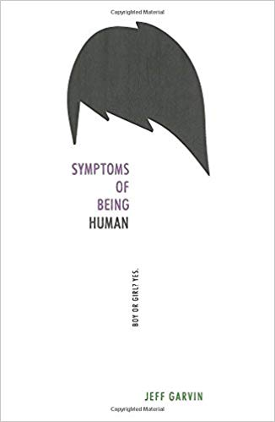
A sharply honest and moving debut perfect for fans of The Perks of Being a Wallflower and Ask the Passengers.

Riley Cavanaugh is many things: Punk rock. Snarky. Rebellious. And gender fluid. Some days Riley identifies as a boy, and others as a girl. But Riley isn't exactly out yet. And between starting a new school and having a congressman father running for reelection in über-conservative Orange County, the pressure—media and otherwise—is building up in Riley's life.

On the advice of a therapist, Riley starts an anonymous blog to vent those pent-up feelings and tell the truth of what it's really like to be a gender fluid teenager. But just as Riley's starting to settle in at school—even developing feelings for a mysterious outcast—the blog goes viral, and an unnamed commenter discovers Riley's real identity, threatening exposure. And Riley must make a choice: walk away from what the blog has created—a lifeline, new friends, a cause to believe in—or stand up, come out, and risk everything.

From debut author Jeff Garvin comes a powerful and uplifting portrait of a modern teen struggling with high school, relationships, and what it means to be human.

Ramona Blue by Julie Murphy

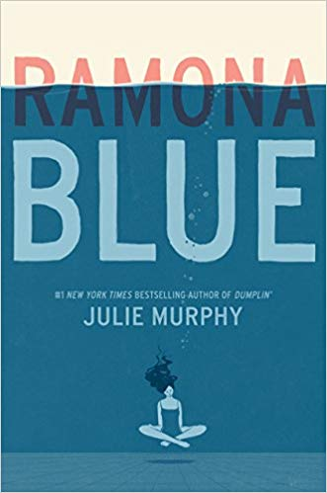
Ramona was only five years old when Hurricane Katrina changed her life forever.

Since then, it’s been Ramona and her family against the world. Standing over six feet tall with unmistakable blue hair, Ramona is sure of three things: she likes girls, she’s fiercely devoted to her family, and she knows she’s destined for something bigger than the trailer she calls home in Eulogy, Mississippi.

But juggling multiple jobs, her flaky mom, and her well-meaning but ineffectual dad forces her to be the adult of the family. Now, with her sister, Hattie, pregnant, responsibility weighs more heavily than ever.

The return of her childhood friend Freddie brings a welcome distraction. Ramona’s friendship with the former competitive swimmer picks up exactly where it left off, and soon he’s talked her into joining him for laps at the pool.

But as Ramona falls in love with swimming, her feelings for Freddie begin to shift too, which is the last thing she expected. With her growing affection for Freddie making her question her sexual identity, Ramona begins to wonder if perhaps she likes girls and guys or if this new attraction is just a fluke.

Either way, Ramona will discover that, for her, life and love are more fluid than they seem.

Out of Darkness by Ashley Hope Pérez
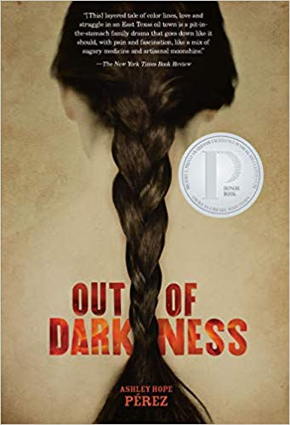
"This is East Texas, and there's lines. Lines you cross, lines you don't cross. That clear?"

New London, Texas. 1937. Naomi Vargas and Wash Fuller know about the lines in East Texas as well as anyone. They know the signs that mark them. They know the people who enforce them. But sometimes the attraction between two people is so powerful it breaks through even the most entrenched color lines. And the consequences can be explosive.

Ashley Hope Pérez takes the facts of the 1937 New London school explosion―the worst school disaster in American history―as a backdrop for a riveting novel about segregation, love, family, and the forces that destroy people.

All American Boys by Jason Reynolds
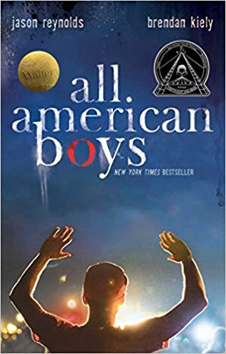
In this New York Times bestselling novel, two teens—one black, one white—grapple with the repercussions of a single violent act that leaves their school, their community, and, ultimately, the country bitterly divided by racial tension.

A bag of chips. That’s all sixteen-year-old Rashad is looking for at the corner bodega. What he finds instead is a fist-happy cop, Paul Galluzzo, who mistakes Rashad for a shoplifter, mistakes Rashad’s pleadings that he’s stolen nothing for belligerence, mistakes Rashad’s resistance to leave the bodega as resisting arrest, mistakes Rashad’s every flinch at every punch the cop throws as further resistance and refusal to STAY STILL as ordered. But how can you stay still when someone is pounding your face into the concrete pavement?

There were witnesses: Quinn Collins—a varsity basketball player and Rashad’s classmate who has been raised by Paul since his own father died in Afghanistan—and a video camera. Soon the beating is all over the news and Paul is getting threatened with accusations of prejudice and racial brutality. Quinn refuses to believe that the man who has basically been his savior could possibly be guilty. But then Rashad is absent. And absent again. And again. And the basketball team—half of whom are Rashad’s best friends—start to take sides. As does the school. And the town. Simmering tensions threaten to explode as Rashad and Quinn are forced to face decisions and consequences they had never considered before.

Written in tandem by two award-winning authors, this four-starred reviewed tour de force shares the alternating perspectives of Rashad and Quinn as the complications from that single violent moment, the type taken directly from today’s headlines, unfold and reverberate to highlight an unwelcome truth.

NON-FICTION

Rhythm Ride: A Road Trip Through the Motown Sound by Andrea Davis Pinkney

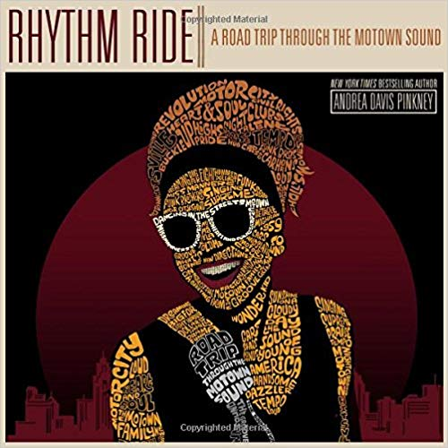
From award-winning author Andrea Davis Pinkney comes the story of the music that defined a generation and a movement that changed the world.

Berry Gordy began Motown in 1959 with an $800 loan from his family. He converted the garage of a residential house into a studio and recruited teenagers from the neighborhood-like Smokey Robinson, Mary Wells, Marvin Gaye, Stevie Wonder, and Diana Ross-to sing for his new label. Meanwhile, the country was on the brink of a cultural revolution, and one of the most powerful agents of change in the following decade would be this group of young black performers from urban Detroit. From Berry Gordy and his remarkable vision to the Civil Rights movement, from the behind-the-scenes musicians, choreographers, and song writers to the most famous recording artists of the century, Andrea Davis Pinkney takes readers on a Rhythm Ride through the story of Motown.

Honor Girl: A Graphic Memoir by Maggie Thrash
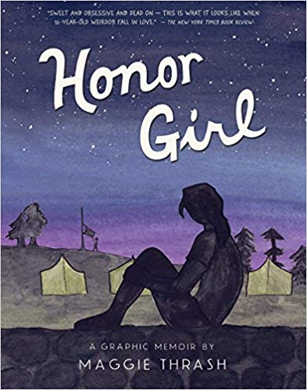
All-girl camp. First love. First heartbreak. At once romantic and devastating, brutally honest and full of humor, this graphic-novel memoir is a debut of the rarest sort.

Maggie Thrash has spent basically every summer of her fifteen-year-old life at the one-hundred-year-old Camp Bellflower for Girls, set deep in the heart of Appalachia. She’s from Atlanta, she’s never kissed a guy, she’s into Backstreet Boys in a really deep way, and her long summer days are full of a pleasant, peaceful nothing . . . until one confounding moment. A split-second of innocent physical contact pulls Maggie into a gut-twisting love for an older, wiser, and most surprising of all (at least to Maggie), female counselor named Erin. But Camp Bellflower is an impossible place for a girl to fall in love with another girl, and Maggie’s savant-like proficiency at the camp’s rifle range is the only thing keeping her heart from exploding. When it seems as if Erin maybe feels the same way about Maggie, it’s too much for both Maggie and Camp Bellflower to handle, let alone to understand.

March: Book One by John Lewis (Author), Andrew Aydin (Author), Nate Powell
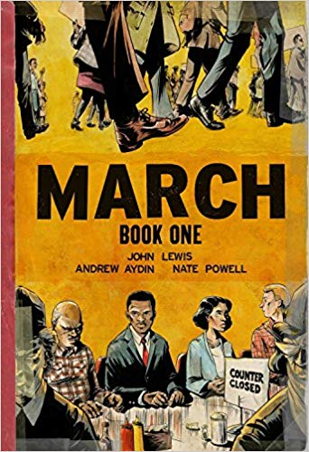
Congressman John Lewis (GA-5) is an American icon, one of the key figures of the civil rights movement. His commitment to justice and nonviolence has taken him from an Alabama sharecropper's farm to the halls of Congress, from a segregated schoolroom to the 1963 March on Washington, and from receiving beatings from state troopers to receiving the Medal of Freedom from the first African-American president.

Now, to share his remarkable story with new generations, Lewis presents March, a graphic novel trilogy, in collaboration with co-writer Andrew Aydin and New York Times best-selling artist Nate Powell (winner of the Eisner Award and LA Times Book Prize finalist for Swallow Me Whole).

March is a vivid first-hand account of John Lewis' lifelong struggle for civil and human rights, meditating in the modern age on the distance traveled since the days of Jim Crow and segregation. Rooted in Lewis' personal story, it also reflects on the highs and lows of the broader civil rights movement.

Book One spans John Lewis' youth in rural Alabama, his life-changing meeting with Martin Luther King, Jr., the birth of the Nashville Student Movement, and their battle to tear down segregation through nonviolent lunch counter sit-ins, building to a stunning climax on the steps of City Hall.

Many years ago, John Lewis and other student activists drew inspiration from the 1958 comic book "Martin Luther King and the Montgomery Story." Now, his own comics bring those days to life for a new audience, testifying to a movement whose echoes will be heard for generations.

Becoming by Michelle Obama

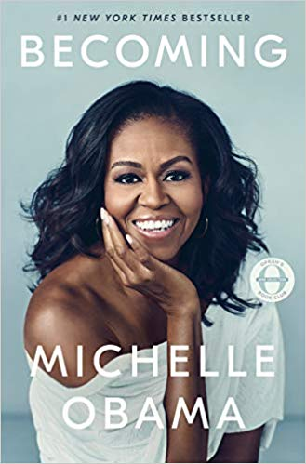
In a life filled with meaning and accomplishment, Michelle Obama has emerged as one of the most iconic and compelling women of our era. As First Lady of the United States of America—the first African American to serve in that role—she helped create the most welcoming and inclusive White House in history, while also establishing herself as a powerful advocate for women and girls in the U.S. and around the world, dramatically changing the ways that families pursue healthier and more active lives, and standing with her husband as he led America through some of its most harrowing moments. Along the way, she showed us a few dance moves, crushed Carpool Karaoke, and raised two down-to-earth daughters under an unforgiving media glare.

In her memoir, a work of deep reflection and mesmerizing storytelling, Michelle Obama invites readers into her world, chronicling the experiences that have shaped her—from her childhood on the South Side of Chicago to her years as an executive balancing the demands of motherhood and work, to her time spent at the world’s most famous address. With unerring honesty and lively wit, she describes her triumphs and her disappointments, both public and private, telling her full story as she has lived it—in her own words and on her own terms. Warm, wise, and revelatory, Becoming is the deeply personal reckoning of a woman of soul and substance who has steadily defied expectations—and whose story inspires us to do the same.
In this memoir, Sandra tells the story of her survival, of finding her place in a new country, of her hope for the future, and how she found a way to give voice to her people.

SPECULATIVE FICTION

An Absolutely Remarkable Thing: A Novel by Hank Green

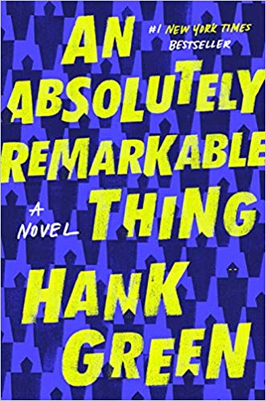
The Carls just appeared.

Roaming through New York City at three a.m., twenty-three-year-old April May stumbles across a giant sculpture. Delighted by its appearance and craftsmanship—like a ten-foot-tall Transformer wearing a suit of samurai armor—April and her best friend, Andy, make a video with it, which Andy uploads to YouTube. The next day, April wakes up to a viral video and a new life. News quickly spreads that there are Carls in dozens of cities around the world—from Beijing to Buenos Aires—and April, as their first documentarian, finds herself at the center of an intense international media spotlight.

Seizing the opportunity to make her mark on the world, April now has to deal with the consequences her new particular brand of fame has on her relationships, her safety, and her own identity. And all eyes are on April to figure out not just what the Carls are, but what they want from us.

Compulsively entertaining and powerfully relevant, An Absolutely Remarkable Thing grapples with big themes, including how the social internet is changing fame, rhetoric, and radicalization; how our culture deals with fear and uncertainty; and how vilification and adoration spring for the same dehumanization that follows a life in the public eye. The beginning of an exciting fiction career, An Absolutely Remarkable Thing is a bold and insightful novel of now.

They Both Die at the End by Adam Silvera

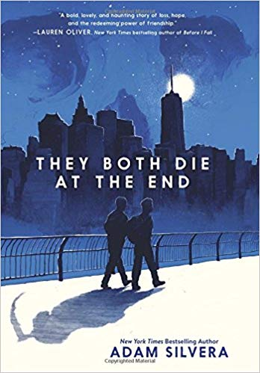
Adam Silvera reminds us that there’s no life without death and no love without loss in this devastating yet uplifting story about two people whose lives change over the course of one unforgettable day.

On September 5, a little after midnight, Death-Cast calls Mateo Torrez and Rufus Emeterio to give them some bad news: They’re going to die today.

Mateo and Rufus are total strangers, but, for different reasons, they’re both looking to make a new friend on their End Day. The good news: There’s an app for that. It’s called the Last Friend, and through it, Rufus and Mateo are about to meet up for one last great adventure—to live a lifetime in a single day.

In the tradition of Before I Fall and If I Stay, They Both Die at the End is a tour de force from acclaimed author Adam Silvera, whose debut, More Happy Than Not, the New York Times called “profound.”

Orleans by Sherri L. Smith

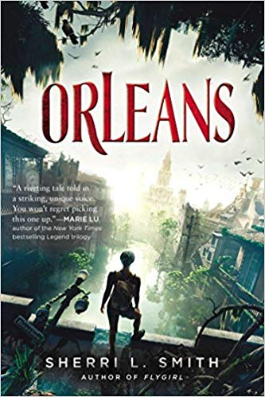
First came the storms.
Then came the Fever.

And the Wall.

After a string of devastating hurricanes and a severe outbreak of Delta Fever, the Gulf Coast has been quarantined. Years later, residents of the Outer States are under the assumption that life in the Delta is all but extinct…but in reality, a new primitive society has been born.

Fen de la Guerre is living with the O-Positive blood tribe in the Delta when they are ambushed. Left with her tribe leader’s newborn, Fen is determined to get the baby to a better life over the wall before her blood becomes tainted. Fen meets Daniel, a scientist from the Outer States who has snuck into the Delta illegally. Brought together by chance, kept together by danger, Fen and Daniel navigate the wasteland of Orleans. In the end, they are each other’s last hope for survival.

Sherri L. Smith delivers an expertly crafted story about a fierce heroine whose powerful voice and firm determination will stay with you long after you’ve turned the last page.

Never Let Me Go by Kazuo Ishiguro

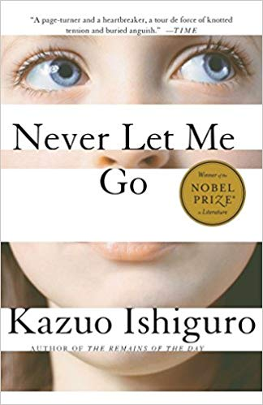
As children Kathy, Ruth, and Tommy were students at Hailsham, an exclusive boarding school secluded in the English countryside. It was a place of mercurial cliques and mysterious rules where teachers were constantly reminding their charges of how special they were. Now, years later, Kathy is a young woman. Ruth and Tommy have reentered her life. And for the first time she is beginning to look back at their shared past and understand just what it is that makes them special—and how that gift will shape the rest of their time together. Suspenseful, moving, beautifully atmospheric, Never Let Me Go is modern classic.

Part Two: In a separate 70-page notebook, write one page on each of the following Common App essay prompts. You do not have to come to school on the first day with a completed essay; instead, you should bring in one page of writing on each prompt. Think about what parts of your life would fit with each prompt and write as much as you can about the question. This is pre-writing. Do not stress if what you write is not well-written or complete. You may write about more than one experience per prompt so long as you have at least one page per prompt. You may write more than a page.

Common App Essay Prompts
1. Some students have a background, identity, interest, or talent that is so meaningful they believe their application would be incomplete without it. If this sounds like you, then please share your story. [No change]

2. The lessons we take from obstacles we encounter can be fundamental to later success. Recount a time when you faced a challenge, setback, or failure. How did it affect you, and what did you learn from the experience? [Revised]

3. Reflect on a time when you questioned or challenged a belief or idea. What prompted your thinking? What was the outcome? [Revised]

4. Describe a problem you've solved or a problem you'd like to solve. It can be an intellectual challenge, a research query, an ethical dilemma - anything that is of personal importance, no matter the scale. Explain its significance to you and what steps you took or could be taken to identify a solution. [No change]

5. Discuss an accomplishment, event, or realization that sparked a period of personal growth and a new understanding of yourself or others. [Revised]

6. Describe a topic, idea, or concept you find so engaging that it makes you lose all track of time. Why does it captivate you? What or who do you turn to when you want to learn more? [New]

