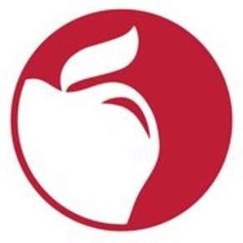

List each production/performance/exhibition for the 2021-2022 school year on the form below and email to UnifiedArts@columbus.k12.oh.us
SCHOOL____________________________________________________
TEACHER_________________________________________
CONTACT INFORMATION____________________________________
PRODUCTION TITLES:

_______________________________________________________________

_______________________________________________________________

_______________________________________________________________

_______________________________________________________________

DESCRIPTION(S)_________________________________________________
_______________________________________________________________
_______________________________________________________________
_______________________________________________________________
DATES AND TIMES________________________________________________
_______________________________________________________________
LOCATION(S)_________________________________________

TICKET PRICES__________________________________________________

