First Name _____________________ Last Name _________________________ Room _________

Mind’s Suitcase planning sheet

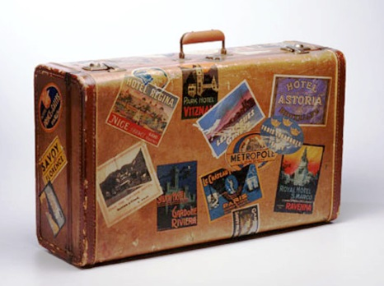

1. Will you use an organic shape or a geometric shape for your suitcase? ________________________

**Tradition-** the handing down of a culture's beliefs and customs from parents

to children over many years. ... It is a tradition in my family to celebrate the New Year with a

special meal.

1. What is a tradition that your family has?

______________________________________________________________________________________________________________________________________________________________________________________________________________________________________________________________________________________________________________________________________________________________________________________________________________________________________________________________________________________________________

1. Tell about a memory you have from past.

______________________________________________________________________________________________________________________________________________________________________________________________________________________________________________________________________________________________________________________________________________________________________________

1. Write a poem, song or rap that you can add to your art work.

___________________________________________________________________________________________________________________________________________________________________________________________________________________________________________________________________________________________________________________________________________________________________________________________________________________________________________

__________________________________________________________________________________________________________________________

5. Make a list of your favorite words or words that mean something

to you that you can add to your project. Practice writing them

in a fancy way.